letsUpgrade Assignment on Cyber security day 6

Name: Vishal Monteiro

Email ID : [vishalmonteiro056@gmail.com](mailto:vishalmonteiro056@gmail.com)

Q1) Create a payload for windows; transfer the payload to the victim’s machine; exploit the victim’s machine.

Solution:

1. First we have to enable ssh; for this open kali🡪 open the terminal🡪 type sudo su - 🡪 put the password (123456) 🡪 type systemctl enable ssh.
2. Type ip a (to get your address)

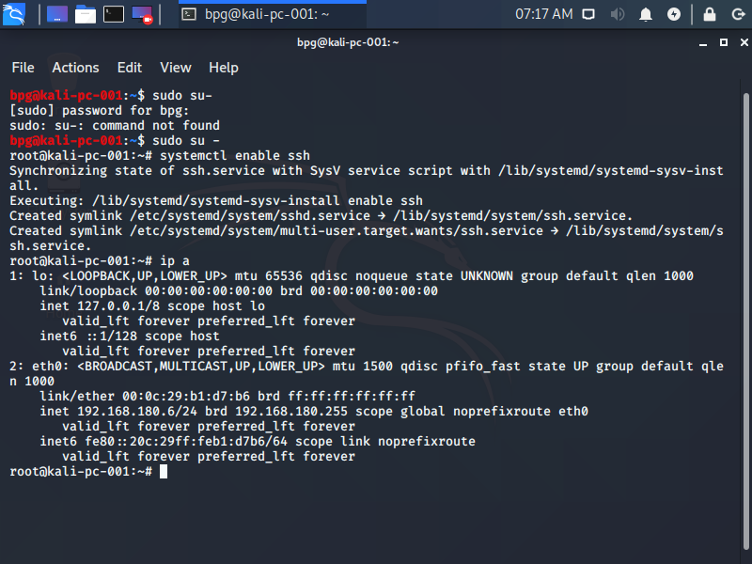

1. We have to download git for windows; for this 🡪 open chrome 🡪 type gitforwindows.org
2. Type ssh bpg@(IP address)🡪 Enter the password.

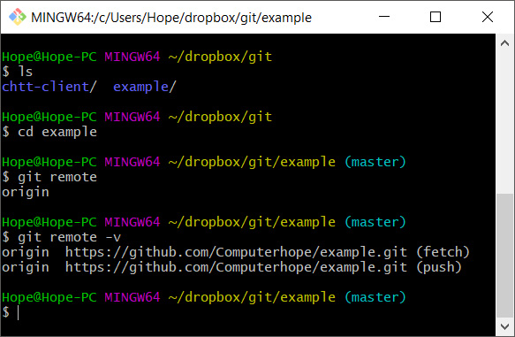

1. Now we have to create a venom using certain commands🡪 (1) create a web server; (2) create a venom (exploit) and host it on web server; (3) let the victim download the venom; (4) wait with a metepreter session using mst console; (5) let victim execute the exploit.
2. We can either use🡪 apt install httpd or apt install apache2

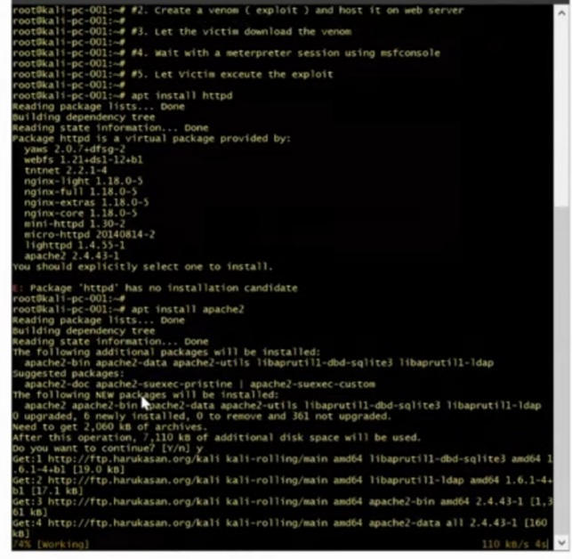

1. To host up a website we have to put🡪 cd /var/www/html/ 🡪 mkdir (name of the file)🡪 cd (name of the file)
2. We paste a link to create venom🡪 and put an extension of .exe 🡪 and put the IP of your kali.
3. Systemctl start apache2 and you are ready to go.
4. Now once the file is downloaded we can get into the system and get the info we need using the commands.

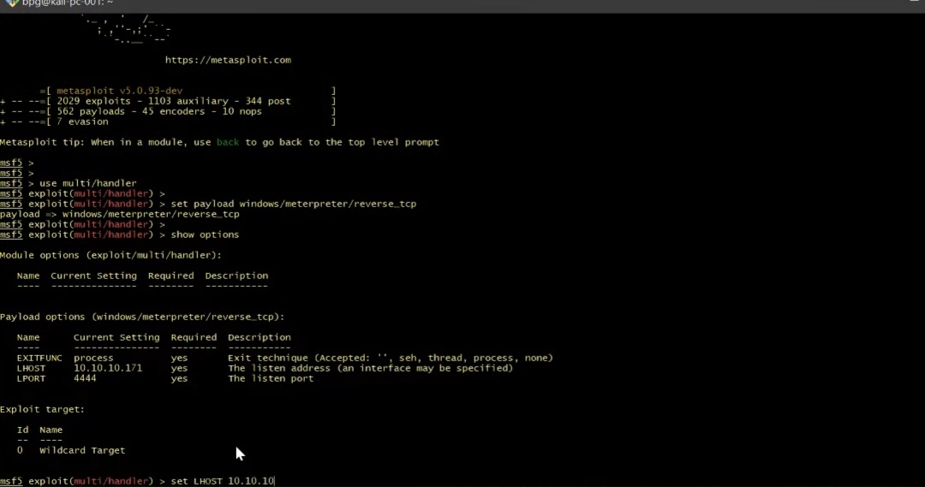

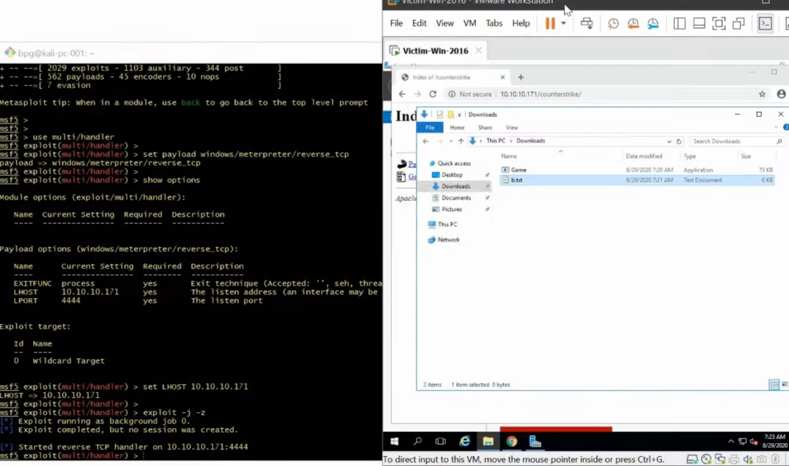

Q2) Create an FTP server; Access FTP server from windows command prompt; DO an mitm and username and password of FTP transaction using wireshark and dsniff.

Solution: